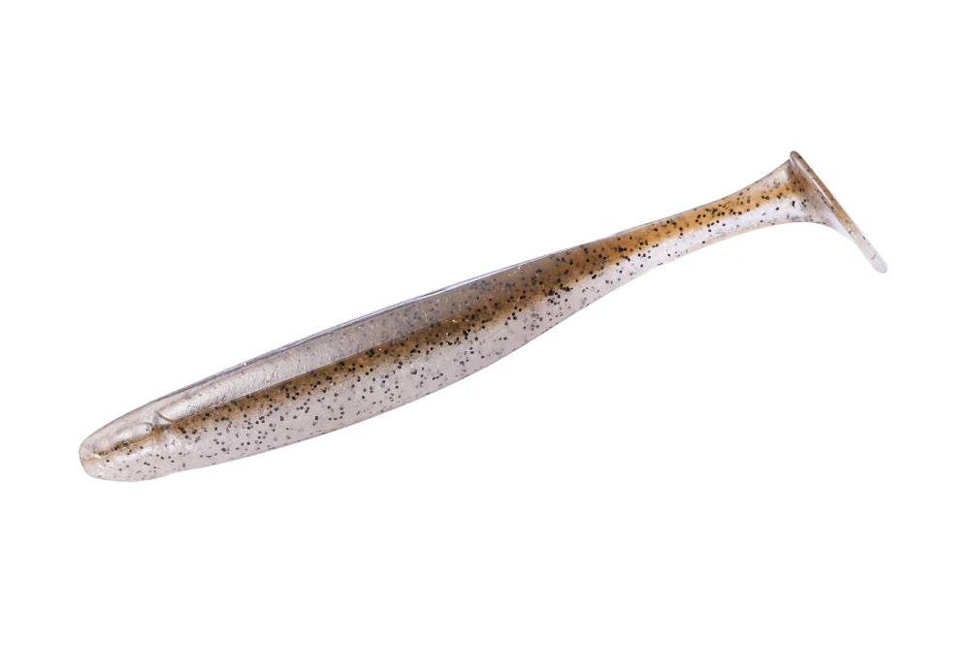
Living the Search
By Wietze Woudwijk
Whether you fish for pike, perch, zander or other predatory fish… they are always on the move. We as anglers have the drive to search for them. This is exactly what Sander, Sascha and Wietze did last week.
The Netherlands, and almost all of Europe, has a huge shortage of water. This is caused due to the huge drought this year, the water levels are almost 2 meters lower than normal. The structures which are normally underwater reveal itself.

In winter, we go out with waiters and now it’s just a matter of walking onto the structure, cast out, and look for the fish. Because of the burning summer, the water temperatures are still sky high. Previous year in October, we had cracking numbers of big perch on the spot we expected them. But this year’s different. The water temperature is still too high and the fish haven started to move yet. This means that the fish aren’t on the spots where we would normally catch them this time around. Therefore its’s searching time.

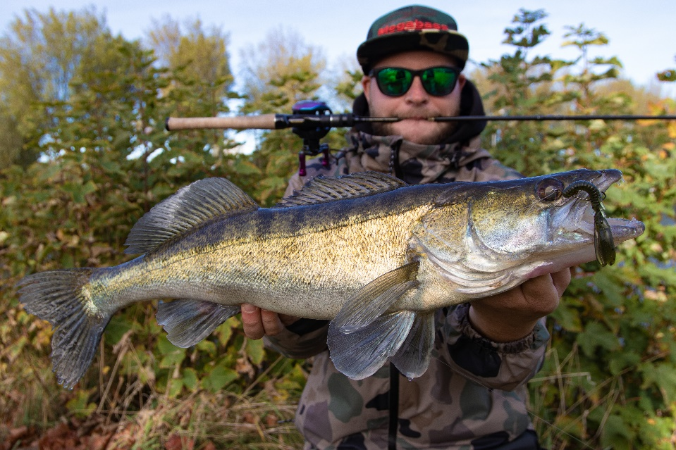
Sascha came to visit us during this autumn to experience the fishing in Holland like we normally do. We took him places and caught multiple good fish. But the weather wasn’t on our side. The autumn like weather made it hard to fish. Wind, rain and complete terror ruled when we were out trying to catch some fish.

All of this changed at the last day of our trip. All of the sudden the sun was there, a little bit cloudy and just enough wind to make the water curve a bit. It is ON! We took a gamble and went to a lake where we caught good fish before.

The first light was just starting to catch onto the horizon. When we arrived we looked over the water and started smiling already, the conditions are perfect! Let’s hope the perch think so to.

Whether you like it or not, fish are still part of nature. They have moment’s they are starving and will take everything you cast in front of them. The other side is that it can be dead still. You can stand there, cast the entire day on your favourite spot because you caught your personal best over there. But unfortunately they are not hungry. This is what we experienced early in the morning. We drove, and drove from spot to spot. Even though our confidence was so high, we didn’t get a tap, hit or nibble on our baits. At around 10 in the morning Sander hooked into the first perch, and man. I will tell you right now, it was a tank. The fish broke the surface of the water, and oefh, will you just look it!

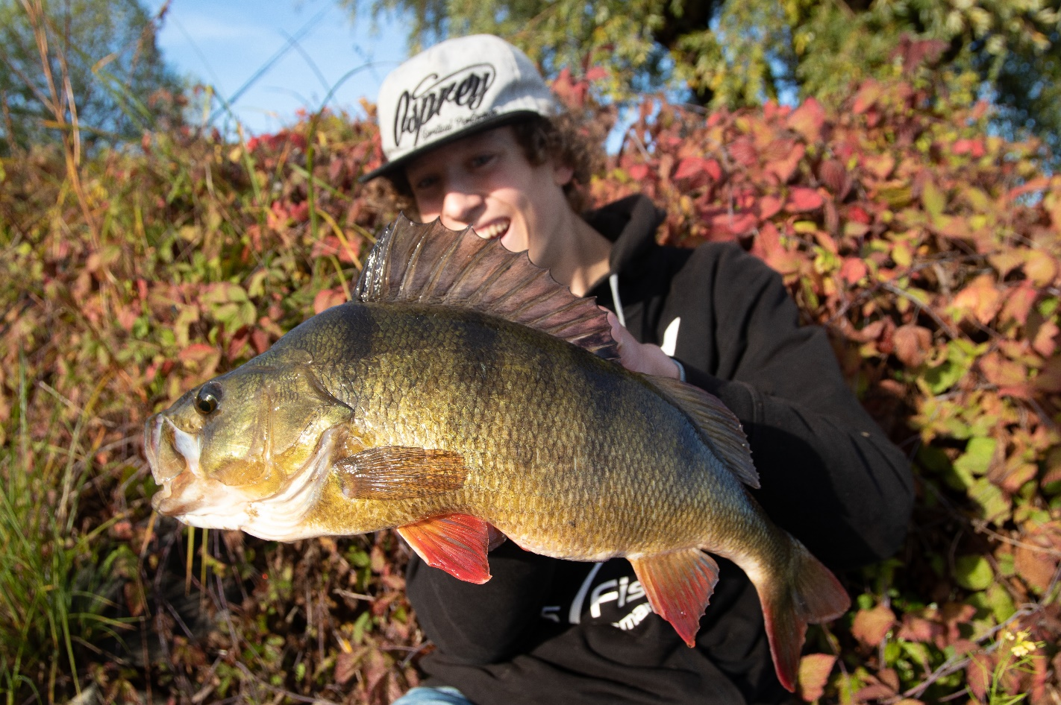

A cracking 49 centimetres, the trick was. Fishing your bait almost dead slowly over the bottom. By using the OSP Dolive Shrimp he could managed to drag the fish over the line to take his bait. And what a stunner it was. Slow was the way to go. Wietze and Sascha changed their jig heads to 3.5 & 5 grams to slow things down. Within 2 casts it was Wietze’s turn. A whopping 48 centimetre perch came by and hit the OSP Dolive Shad, he inhaled it, ripped & tore it in half. So what!? A monster fish was caught. Things kept going, Sascha’s turn… all of the sudden we heard him shout “FISH!” And yes, rod was bend completely. And man, just look at the sick girth on these stunners.
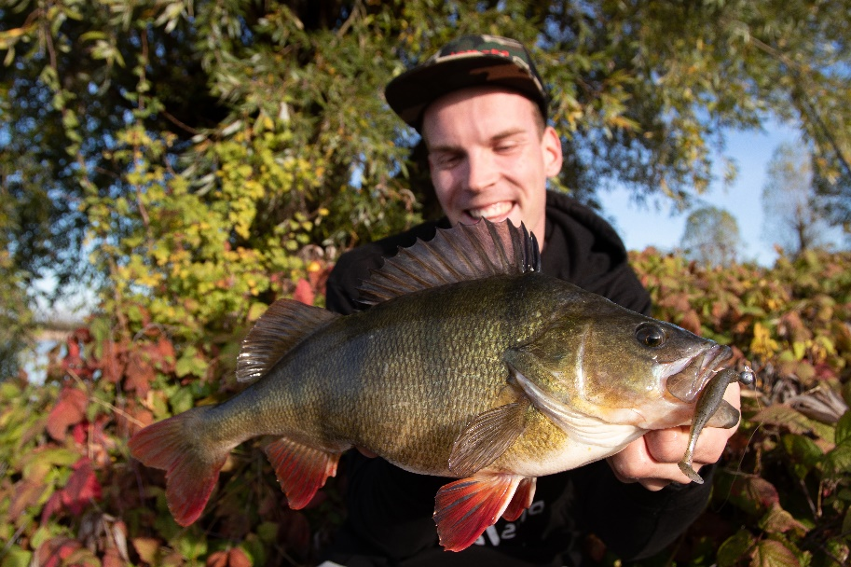
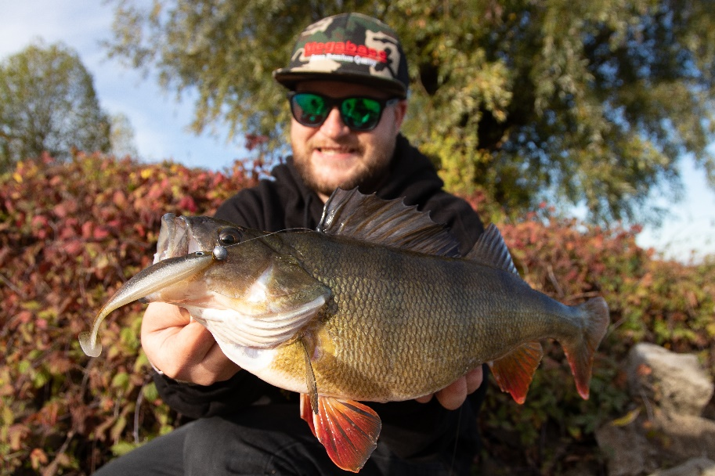

After the fishing slowed down again we moved up to a new place. By using the same method as before things got even crazier! Sander hooked an insane fish. He landed; what even the Dutch boys call “A freaking PIG!”. The fish rose to the surface of the water. And WOW! If even I had a GoPro to record it…

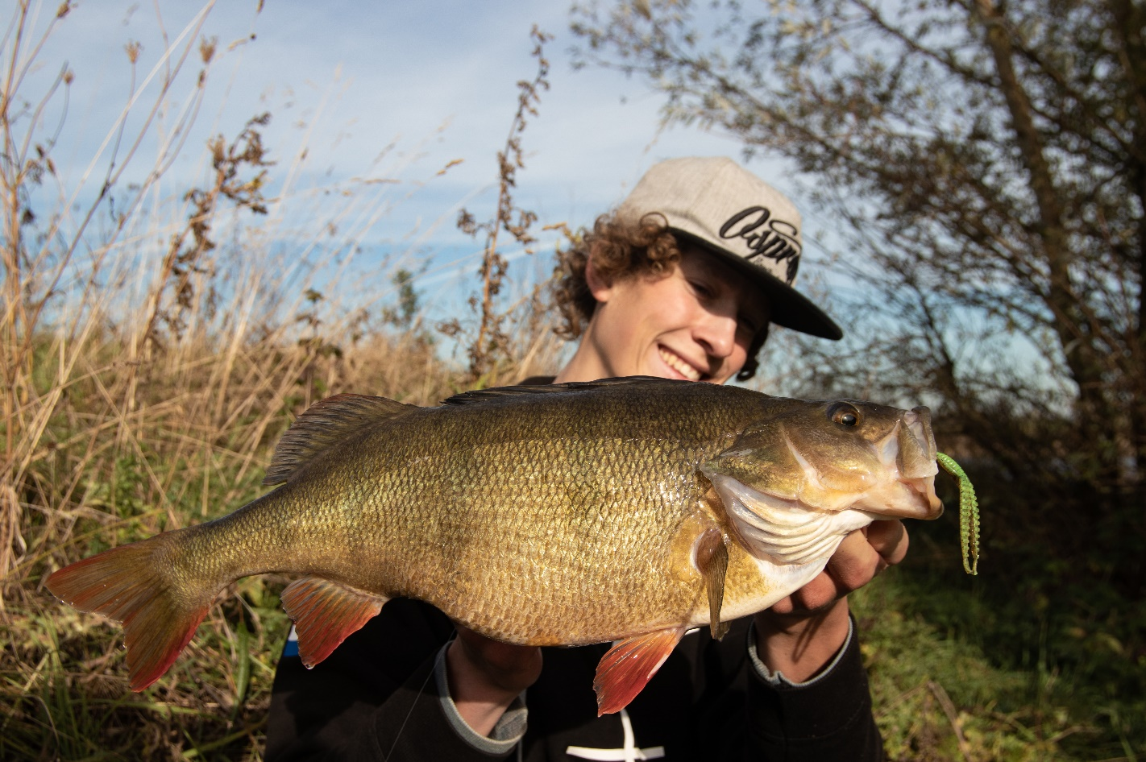

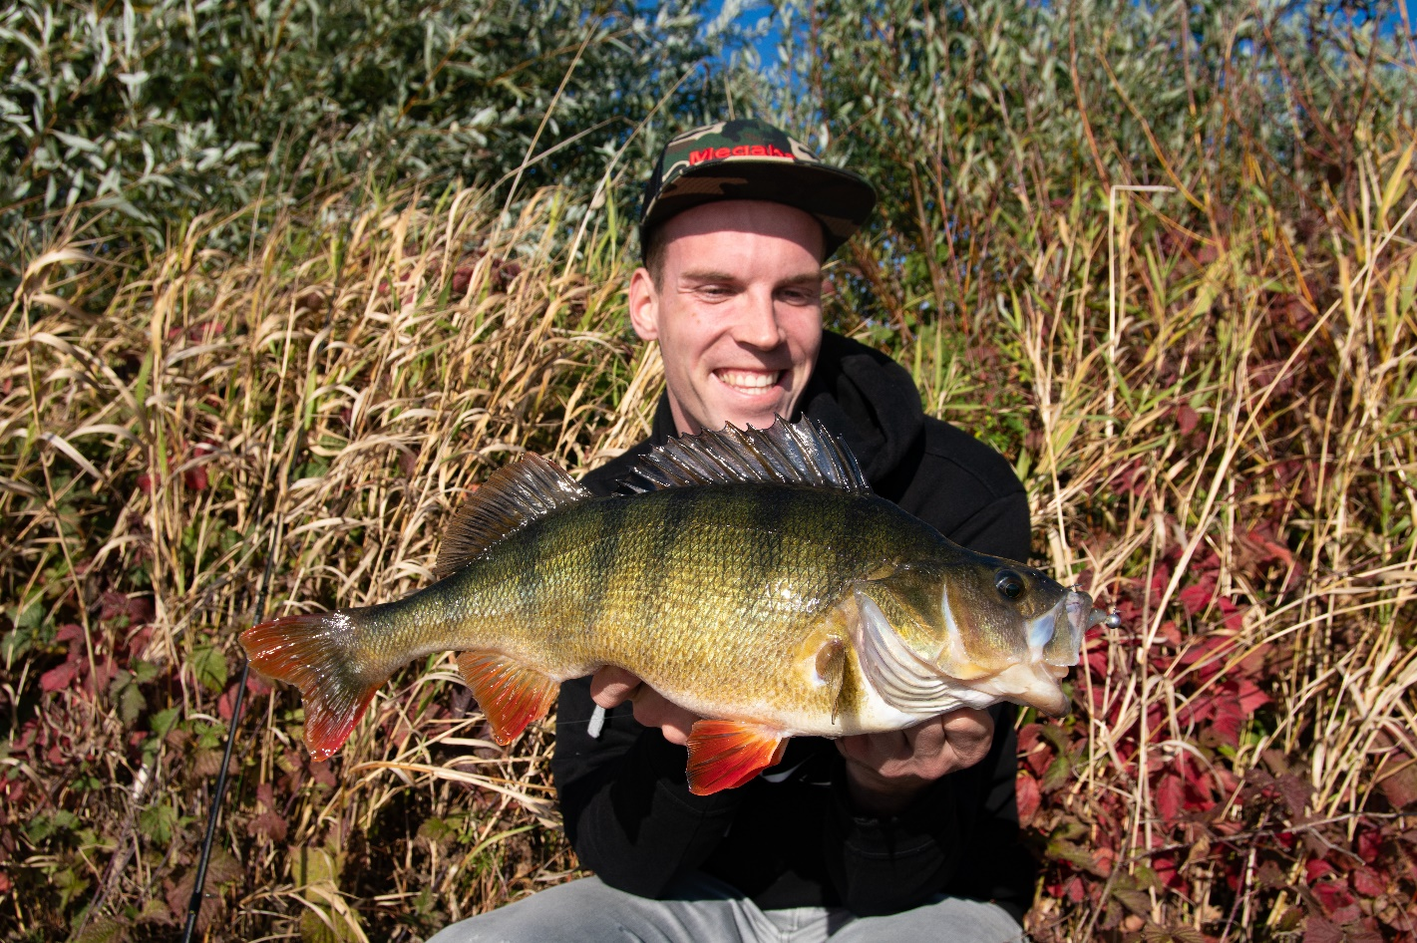
There is the smile of a man who succeeded to catch a 50 cm plus perch again! A living football in the depths of a deep lake. Using the Dolive Shirmp…
I am writing this article now, and still reliving that moment. It is almost indescribable. We were completely amazed by how this fish looked, it was already getting fatter and fatter. Mission Complete!
Fish can be tricky sometimes, they follow your lure from the deep edges in the water until you’re almost lifting it up out of the water. Well, Wietze had this moment, fishing it near an edge all the way to his toes. Then out of nowhere a hard rip on the end of the line. Hooked up! And man, this one took a screamer, big run towards the unknow playground of the deeper water. Sander helped out landing this beast. Another big cherry witch is helping to make this last day perfect!

Wait, SASCHA WAT ARE YOU DOING!? All of the sudden Sascha hooks into a big one as well! Oh no, Sander hands me the camera and runs as fast as possible to help out. Guess what… Another big 40+ fish for Sascha! The perch are coming one after another. Well baby, let’s take a picture? Of course!
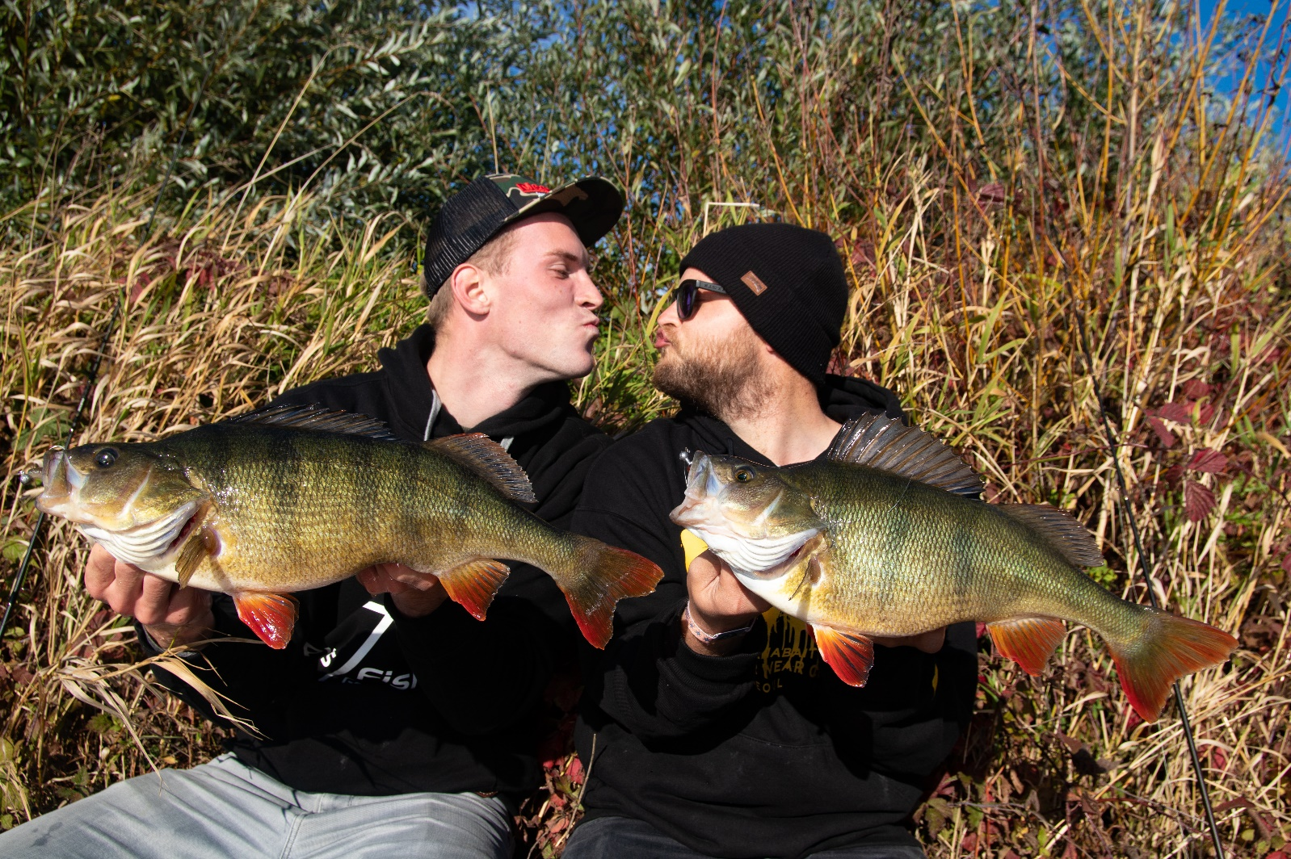
It are moments like these that make a day unforgettable! We were so happy that finally the last day turned out to be so good. The fishing, the company and the weather. Everything fell in place the last day. Sascha & Wietze hooked up two huge perch. We released the stunners and watched them swim away, just as it should be.
So, here’s the story of 3 crazy guys, who had to drive an insane amount to find the right place, moment & company to have a unforgettable day. It was such an adventure! So I will quit writing now and make sure to go out fishing myself. I know Sander & Sascha are out as well. Talk to you guys soon! Oh if you are curious how we caught them and what we experienced these days… make sure to keep an eye out on my YouTube channel! I’ll make sure to subtitle the video’s
Wietze

